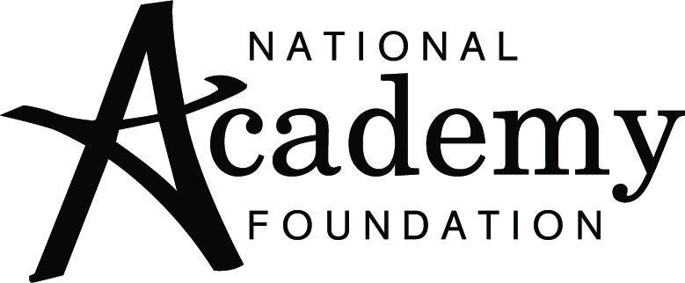

Partnership Agreement
2010/2011

In the promotion of understanding and cooperation between businesses and schools within the
___________ community

Name/Business/Organization and Academy/District

agree on this ________day of_________, 2010 to enter into a formal partnership to connect National Academy Foundation (NAF) Academy students to work-based learning opportunities.

The intent of this partnership is to increase opportunities for Academy students to be introduced to industry expertise to learn valuable skills that will help them prepare for future success in college and in the workforce.

The mission of NAF is to sustain a national network of career academies to support the development of America's youth toward personal and professional success in high school, in higher education, and throughout their careers.

NAF Academies function as dynamic partnerships and collaborations between schools, teachers, administrators, business volunteers, and an active Advisory Board led by industry professionals and key stakeholders.

NAF Partners:
- Participate in monthly meetings with Academy Directors and staff to review and discuss curriculum implementation and the integration of classroom and workplace experiences;
- Generate opportunities for teachers and students to access compensated internships and other meaningful work-based learning experiences year-round;
- Attract and cultivate new and existing Advisory Board members as core partners in the NAF Academy model.
The following is a sample of partner opportunities that enhance course curriculum and add value to student’s work-based learning experiences:

- Advisory Board Member,
- Internship Provider,
- Mentor,
- Classroom Speaker,
- Job Shadow Host,
- Assist with development of work-based learning activities,
- Participate in Mock Interviews, Student Exhibitions and other career-themed activities.

The effectiveness of this partnership will be measured by:

- Completion of designated activities
- Consistent feedback from all participants involved in partner activities
- Timely communication between school and industry partners
- Completion of shared goals and expectations
- Mid-year and end-of-year partner survey
- Active participation in the NAF Collaboration Network

In reciprocation and appreciation, the academy will:

- Academy and NAF staff will work together to recognize all new partnerships publically (newsletters, websites, school/district communication)

- Academy staff will regularly share calendar of events and invite partners to appropriate school activities

- Academy director will share noteworthy partner activities with District and NAF Communications Manager for local and national media outreach

- Academy staff will send letter/other appreciation/recognition to partner’s supervisor at employer

As partners committed to increasing relevant opportunities for students, we pledge our commitment to cooperatively achieve the goals stated in this agreement.

Name, Title Superintendent
Business/Organization

Name, Principal Name, Academy Director
School/NAF Academy` School/NAF Academy

